LIST OF NEW YORK’S
BASEBALL SITES
Major League Stadiums and related sites

The New York metropolitan area is the scene of some of the most legendary events and home of the greatest figures in baseball history. From the first recorded baseball game at Elysian Fields in 1846, New York has been the “Capitol of Baseball” for 171 years.
New York’s baseball history is written in many places – legendary stadiums, distinctive hotels, ordinary homes. Some of these sites are well-marked and internationally-known – others are marked with small plaques, tiny reminders, or even nothing at all. But every one of these sites listed played a major role in the history of baseball, is worth a visit, and deserves to be known and remembered. Enjoy!

- Yankee Stadium (161st Street and River Avenue, The Bronx) Accessible by the No. 4, D, and B trains from Manhattan. The new Yankee Stadium, opened in April 2009. Costing $2.3 billion, it stands one block north of the original, on the 24-acre former site of Macombs Dam Park, and incorporates reproductions of many features from the original Yankee Stadium across the street, including the frieze, the Indiana limestone exterior, hand-operated scoreboards, the section numbering, and the unusually-shaped outfield dimensions. New features include a museum of Yankee history that displays Thurman Munson’s locker, a Great Hall on 161st Street, and an accessible Monument Park. Home plate was brought from the original Stadium, and Yankee relief pitcher and future Hall of Famer requested that the team reposition the home bullpen and provide it with a door to link it with Monument Park.
- Heritage Park/Old Yankee Stadium (161st Street and River Avenue, The Bronx) Accessible by the No. 4, D and Be trains from Manhattan. Demolition of the original stadium began on November 4, 2009, and was completed on May 13, 2010. Heritage Park was opened in April 2012, a multi-use community park that offers residents softball and soccer fields, playground spaces, and a blue outline that shows the location of the original Yankee Stadium interwoven into the grass. Other features that honor the original Stadium include the preservation of a section of the frieze from the old Stadium in the park’s northwest corner, and a pedestrian walkway from the Metro-North commuter rail station to the new stadium, whose paving stones offer highlights from the stadium’s long history in chronological order. Also preserved is the old stadium’s legendary bat-shaped recycling chimney with its Hillerich & Bradsby seal and Babe Ruth’s signature. It also offers benches and plaques honoring Lou Gehrig’s legendary speech, Nelson Mandela declaring himself a Yankee, and Billy Joel’s concert. Viewfinders enable visitors to peer at historic photographs of great events of Yankee Stadium’s past from differing angle.
- Polo Grounds (157th Street and 8th Avenue, 2971 8th Avenue, Manhattan) Accessible by B and D trains to 155th Street-8th Avenue) The last of the four homes to the New York Giants was built as the result of a 1911 fire that shattered the third. The Giants played there until moving to San Francisco in 1957, the Yankees as their tenants until 1922, and the Mets for their inaugural seasons in 1962 and 1963. Demolition began on April 10, 1964. Today the site is occupied by the Polo Grounds Towers, a New York City housing project, and has a marker honoring the site of home plate and another on 2971 Eighth Avenue, that says: “This development was built on the location that Willie Mays and the Giants made famous. Let’s keep it beautiful.”
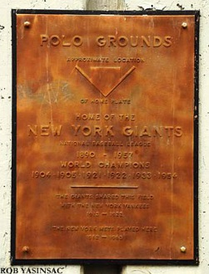

- John T. Brush Memorial Stairs (157th Street and Edgecombe Avenue) Accessible by C Train to 155th Street) The sole remaining actual piece of the Polo Grounds is this unusual item, a staircase built in 1913 to provide fans with access from the heights of Coogan’s Bluff down to the Harlem River Driveway and to the ramps that led down to the Polo Grounds. This staircase and ramp made the Polo Grounds unique among baseball stadiums, in that it was the only one that could be accessed by fans going down a cliff or hill. In addition, the Giants paid for and dedicated a plaque on the staircase that honored their team’s late owner, John T. Brush, who had recently died of tuberculosis. The staircase was preserved after the Polo Grounds was torn down to provide local residents with access from the heights of Edgecombe Avenue to the lower level of the Harlem River Driveway, but was neglected. In the last few years, the city, joined by the Polo Grounds’ original tenants: the Yankees, Mets, Giants, New York Jets football team, and New York Giants football team, teamed up to restore it, along with adding a picnic area, a clean-up effort and murals depicting New York Giants baseball stars created by local artists. South of the site is St. Nicholas Place. Willie Mays lived in his rookie season with the Goosby family at the corner of St. Nicholas Place and 155th Street, and would play stickball with local youth. That portion of St. Nicholas Place is named in Mays’ honor.
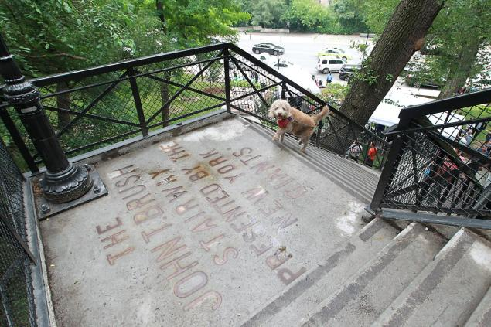

- Hilltop Park (168th Street and Broadway. Accessible by A, C, and 1 trains to 168th Street) The original home of the New York Yankees from 1903 to 1912 is now mostly the Columbia-Presbyterian Medical Center. The rocky and hilly terrain – combined with the British Royal Highland Regiment (the Black Watch) fighting the Continental Army there in 1776 – gave the Yankees their original name of “Highlanders,” which they dropped when the team’s lease at Hilltop Park expired and they moved to the Polo Grounds, becoming tenants of the Giants until 1922. The stadium was demolished in 1914, but in 1993, with the cooperation of SABR, the Yankees, and Columbia-Presbyterian, a plaque was dedicated to honor Hilltop Park.
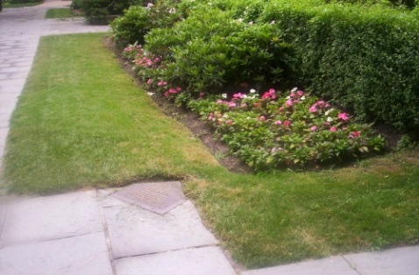
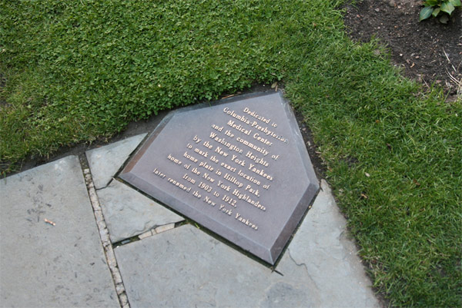
- Dyckman Oval (204th Street and 10th Avenue, 1 train to Dyckman Street) Opened in 1920 and home to a variety of Negro League teams, the Dyckman Oval was the second major league stadium in New York to have lights. Babe Ruth played exhibition games there after his major league career ended, smacking his last home runs in competition. The New York Cubans (in several guises) played their home games there, under their colorful owner, the morally questionable but community-concerned Alejandro (Alex) Pompez, who made his fortune as a numbers king, earning an incredible $8,000 per day in the 1920s. Forced to sell his racket to Dutch Schultz in 1931, Pompez turned to baseball, but he and the stadium were brought down by the “Racket-Busting DA,” Tom Dewey – the stadium falling in 1938, Pompez pleading guilty to conspiracy in 1939. Pompez died in 1974, and was elected to the Hall of Fame in 2006. The New York Cubans moved to the Polo Grounds in 1943 and folded in 1950. Dyckman Oval became the Dyckman Homes Housing Project in 1951.
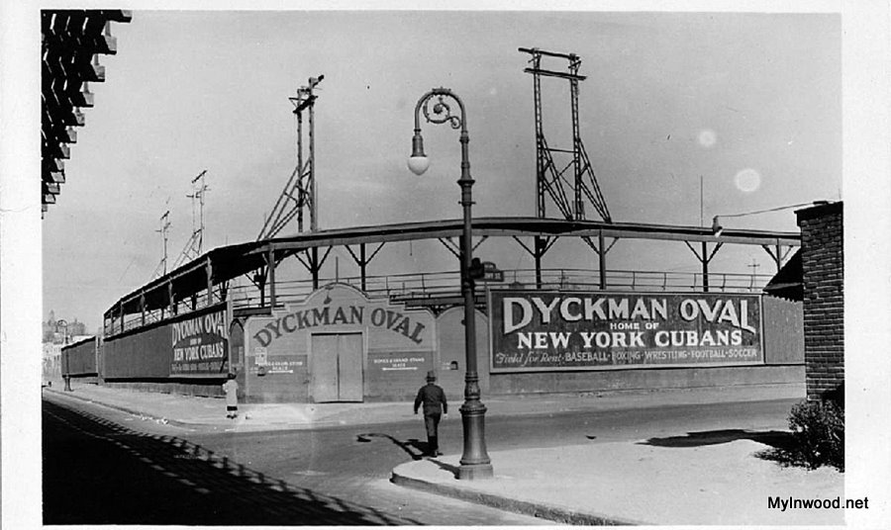

- Ebbets Field (McKeever Place and Sullivan Place, B, Q, S trains to Prospect Park) Known throughout baseball for its unusual angles, rotunda entrance, unique features, and legendary fans, Ebbets Field was opened in 1913 and served as the home of the Brooklyn Dodgers until their departure for Los Angeles in 1957. Only one man ever won that “free suit” from Abe Stark, when Woody English hit the sign on June 6, 1937. When Braves hitter Bama Rowell hit a blast off Dodgers pitcher Hank Behrman in the second inning of a doubleheader nightcap on May 30, 1946, everybody knew it was 4:25 p.m. because Rowell’s shot smashed the scoreboard’s Bulova clock, covering Dodger right fielder Dixie Walker in shattered glass. However, the clock “kept ticking” for another hour. The Bulova Company promised a free watch to anyone who hit the clock, but Rowell did not receive his timepiece until 41 years later, on Bama Rowell Day in his hometown of Citronelle, Alabama. This event inspired the legendary clock-smashing scene in the novel and movie “The Natural.” When the ballpark was opened in 1913, management discovered it lacked a flag, the keys to the bleachers, and a press box. While the first two problems were solved easily, the press box was not installed until 1929. Demolition of the stadium began in 1960. The same wrecking ball was used four years later on the Polo Grounds. The cornerstone and other pieces of the park went to Cooperstown, while eight light towers went to Downing Stadium on Randall’s Island, and many other souvenirs were auctioned off on April 20, 1960. The flagpole now stands before the Barclay Center at Atlantic Avenue. Interestingly, the Dodgers have now played more games in Los Angeles than at Ebbets Field, while the Mets played the same length of time at Shea Stadium as the Dodgers at Ebbets Field, with two World Championships to the Dodgers’ one. The site is now occupied by the Jackie Robinson Apartments (originally the Ebbets Field Apartments) which are opposite Jackie Robinson Intermediate School. In 2014, a die-hard Dodgers fan purchased the street sign that stood at the corner of McKeever Place and Montgomery Street for decades, paying $58,852.08.
- Washington Park (Third Avenue and Third S Street, Brooklyn, D, N, R, W trains to 9th Street, F, G trains to 4th Avenue). In its four incarnations, this stadium was the home of the Brooklyn Atlantics, Brooklyn Bridegrooms, The Federal League Brooklyn Tip-Tops, and even the 1887 New York Mets. The original stadium’s original baseball clubhouse was George Washington’s headquarters during the Battle of Long Island during the American Revolution, where 400 Maryland troops stood off 2,000 Hessian troops. The Hessians never won a battle unless actual British troops were present, and there weren’t any British troops present, the Hessians maintained their losing streak until British troops showed up to kill 259 and wound 100 Americans. The historic building was reduced to rubble in the 20th century, then rebuilt, and still stands. The third park was the site of a famous literary baseball appearance: Archibald “Moonlight” Graham’s actual one inning in the outfield for the World Champion 1905 New York Giants, depicted accurately in the book “Shoeless Joe” and moved to 1922 in the movie “Field of Dreams.” Watching games at the third and fourth stadium was an olfactory experience because of nearby factories. The left-centerfield wall of the third park survives as the edge of a Con Edison storage yard.
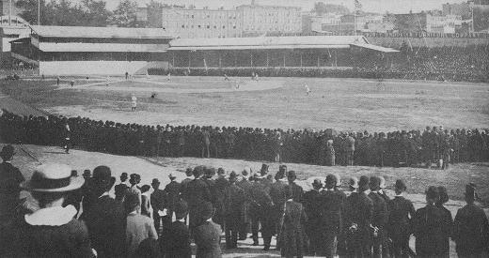
- Dexter Park (Elderts Lane/Dexter Court and 75th Jamaica Avenue, J, Z trains to 75th Street). Home of the Eastern Colored League Brooklyn Royal Giants from 1923 to 1927, the Negro National League New York Cubans and New York Black Yankees in the 1930s and 1940s. Legend had it that the park replaced a racetrack and the stadium’s name honored a horse named “Dexter” buried on the site. In fact, it was named for Charles Dexter, who operated the horse shed. The stadium was the first in New York to host a night game, doing so on July 23, 1930. Josh Gibson himself smacked a mammoth home over the 30-foot high wall behind the left-center bleachers at the 418-foot sign. The stadium bore perhaps the most creative billboard ever, from an optometrist, which read: “Don’t Kill the Umpire – Maybe It’s Your Own Eyes.” While numerous Negro League titans like Gibson, Smokey Joe Williams, so did Babe Ruth, Lou Gehrig, Phil Rizzuto, Hank Greenberg, and even future Yankee announcing legend Bob Sheppard, in his role as St. John’s University quarterback. The stadium was adapted for stock car racing in 1951 and used for that until 1956. The last baseball game there was on May 18, 1957, between St. John’s University and City College of New York. The park was torn down in June 1957.
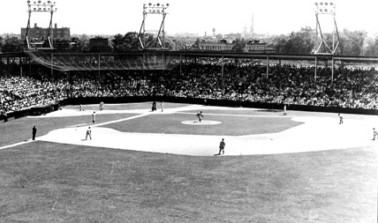

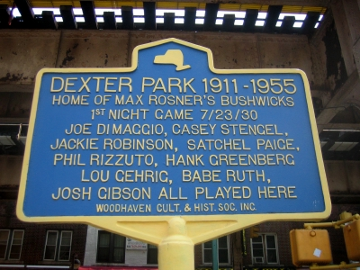

- Shea Stadium (Roosevelt Avenue and Grand Central Parkway, 7 train to Willets Point-Mets) The second home of the New York Mets was also used as the home of the New York Yankees in 1974 and 1975 while the original Yankee Stadium was being renovated. The stadium was christened on April 16, 1964, with Dodger holy water from the Gowanus Canal in Brooklyn and Giant holy water from the exact location the Harlem River passes the Polo Grounds. In 1998, a fallen beam at the old Yankee Stadium resulted in the Yankees playing a day game against the Los Angeles Angels at Shea – and winning it on a Darryl Strawberry home run – followed by the Mets winning their scheduled game against the Chicago Cubs that evening. This was the first time in the 20th century that one ballpark housed two games for four different American and National League teams in the same day. At the time of its construction in 1964, Shea Stadium offered many new features – the field sections on movable rollers to accommodate differing needs for football and baseball games, and a light ring around the roof instead of light towers. The foul lines were marked at 330 feet in 1964, but when measured in 1965, discovered to actually be 341. The most unusual at-bat in the stadium’s history came on July 13, 1977, when Met third baseman Lenny Randle stood in against Chicago Cub pitcher Ray Burris, watched Burris uncork his pitch, and everything turn black. Randle presumed he had been hit by the pitch and gone to the next world. In fact, it was 9:34 p.m. and the great blackout of 1977 started. Burris hung on to the ball. With the lights out, emergency lighting kicked in, and fans and players were trapped. The Mets drove their cars onto the field and used their headlights to illuminate the infield and played a fake game to entertain fans. Stadium organist Jane Harvis, Shea’s “Queen of Melody,” played “Jingle Bells” and “White Christmas.” The game was suspended with the Mets trailing 2-1, and finished on September 16, with the Cubs winning 5-2. The red Big Apple that rises out of a hat when a Met hits a home run was installed in 1981 and moved to the Citiffield in 2009, and now stands outside of the new stadium. When the stadium was closed in 2008, the company with the rights to sell memorabilia were given two weeks to do. Seats were sold at $869 per pair, plus tax, a combination of the Mets’ two World Championship seasons, 1969 and 1986. Demolition began on October 14, 2008. As the stadium was City property, much of the stadium’s equipment, including bathroom fixtures, were re-used in municipal facilities across New York. The sites of home plate, the pitcher’s mound, and the bases are immortalized in the Citifield parking lot that now occupies the site of Shea Stadium.
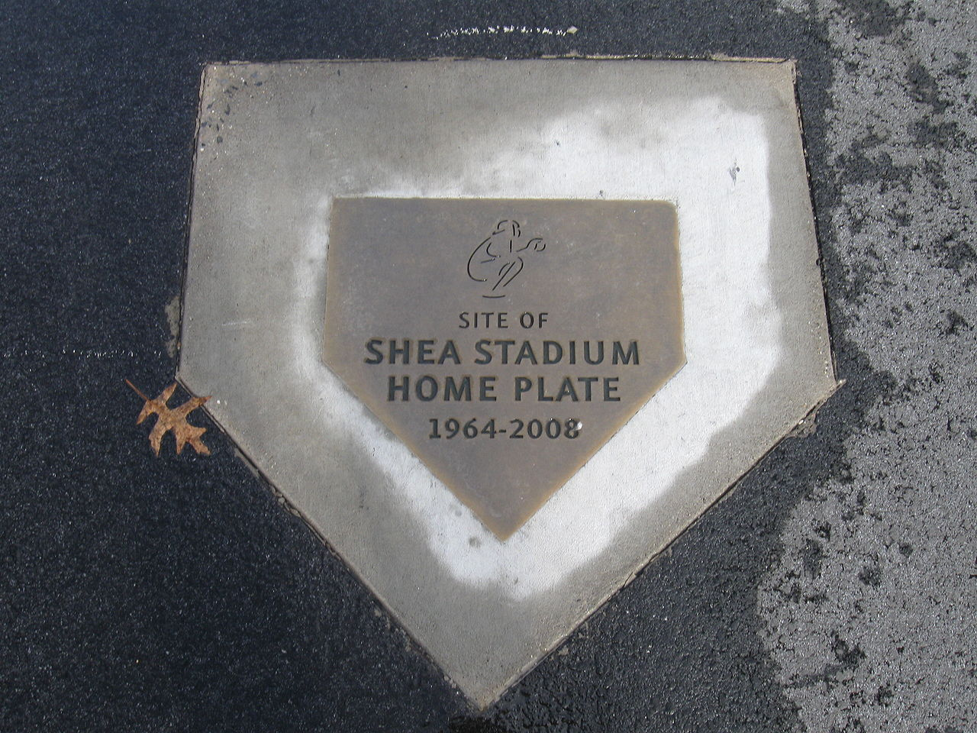

- Citi Field (Roosevelt Avenue and Grand Central Parkway, Queens, 7 train to Willets Point-Mets) Opened in 2009, the stadium’s design is a intended as homage to Ebbets Field with the exterior façade and rotunda honoring Jackie Robinson. Internally, there are features that honor the Polo Ground – visible steel beams and all seats being green, as well as a right-field overhang. The outfield section also offers a pedestrian bridge named Shea Bridge, designed to resemble the Hell Gate Bridge and be a symbolic bridge to the city’s past National League teams. In 2012, the Mets added the City Party Deck in left field, along with the original top of their main Shea Stadium scoreboard. While the stadium drew rave reviews from architecture and food critics, Met fans were less impressed in how it honored the Brooklyn Dodgers’ legacy while ignoring the achievements of the Mets. Met owner Fred Wilpon, admitting that error in judgment, moved to install photographic images of famous Mets and historic moments, display team championship banners, and open a Mets Hall of Fame and Museum, while adding new members to the Hall. Another issue with the new park is that for its first three years, it was a “pitcher’s park,” which seriously decreased the home run production of Met sluggers David Wright and Jason Bay. The Mets did not have a no-hitter in the team’s history until June 1, 2012, when Johan Santana ended the 50-year drought at the expense of the St. Louis Cardinals, 8-0.
Additional Stadiums
MANHATTAN
Polo Grounds (I)
Home to the Metropolitans (Mets), and the Giants
110th Street (south, right field for Mets, third base for Giants); Fifth Avenue (east, first base for Giants); Sixth (now Lenox) Avenue (west, third base for Mets); 112th Street (north, left field for Mets, right field for Giants) Nearest subway station: 110th Street, B, C trains.

Metropolitan Park
Home to Metropolitans
109th Street (north); East River (east); 107th Street (south); First Avenue (west)

BROOKLYN

Atlantic Ground
Marcy Avenue between Putnam and Gates Avenues.
Home to the Atlantic Club (before the club moved to the Capitoline Grounds), and the Enterprise Club, among others. Nearest subway station: 110th Street, 6 train.
Capitoline Grounds
Marcy Avenue (east); Halsey Street (south); Putnam Avenue (north); Nostrand Avenue (west) in Bedford-Stuyvesant
Home to the Atlantics, the Enterprise, and the Excelsior Clubs.

Carroll Park Grounds
First field, bounded by Smith, Hoyt, Degraw, and Sackett Streets.
Second field, bounded by Smith, Hoyt, Carroll, and President Streets.
Modern park, between President and Carroll Streets east of Court Street.
Home to the Excelsior, Star, Marion, Waverly, Alert, Esculapian, Typographical, Independent, and Charter Oak Clubs. Center fielder Henry Chadwick played here.

Continental Grounds
Lee and Bedford Avenues, Ross and Hewes Streets.
Also known as the Wheat Hill Grounds, and the Putnam Grounds (I).
Home to the Continental, the Putnam, the Resolute and the Sylvia Clubs.

Eastern Park
Eastern Parkway (segment later renamed Pitkin Avenue when Eastern was diverted) (north, home plate); Long Island Railroad and Vesta Avenue (later renamed Van Sinderen Street) (east, left field); Sutter Avenue (south, center field); Powell Street (west, right field)
Home to Brooklyn Ward's Wonders, and the Brooklyn Dodgers.

Excelsior grounds (I)
Carroll Gardens, Brooklyn
Home to the Excelsior Club.

Excelsior grounds (II)
Red Hook, Brooklyn – south end of Court Street, on the waterfront (Gowanus Canal)
Home to the Star and the Excelsior Clubs.

Long Island Cricket Club Grounds
Terminus of the Fulton Avenue Railroad, Bedford, corner of Nostrand Avenue and Fulton Avenue.
very first home of the Atlantic Club, obviously sharing with the Long Island Cricket Club. the Long Island Club hosted and handily won a cricket match with the Brooklyn Club, Later, the ground was occupied by the Pastime Club,

The Manor House Grounds
Nassau and Driggs Avenues, and Russell and Monitor Streets, or very near there.
Also known as the Eckford Grounds and the Greenpoint Grounds.
Home to the Eckford and the Wayne Clubs, as well as the Satellite Cricket Club.

MCU Park (formerly KeySpan Park)
Coney Island, Brooklyn – 1904 Surf Avenue – Surf Avenue (north, third base); Kensington Walk (east, left field); Boardwalk (south, right field); West 19th Street (west, first base)
Home to the Cyclones. Nearest subway station: Coney Island. N, D, F, Q trains.

Putnam Grounds (II)
Broadway between Lafayette and Gates Avenues.
Home to the Putnam, Constellation, Harmony, and the Oriental Clubs of Bedford.
Satellite Ground
Broadway, Harrison Avenue, Rutledge and Lynch Streets. This enclosed ground stood directly across Harrison Avenue from the Union Grounds.
Home to the Fulton and Resolute Clubs.

Union Grounds
Williamsburg, Brooklyn – Marcy Avenue (southwest); Rutledge Street (northwest); Harrison Avenue (northeast); Lynch Street (southeast)
Home to the Eckfords, Mutuals, Atlantics, and "Hartford of Brooklyn"

Union Star Cricket Club Grounds
Fort Greene - corner of Myrtle and Portland Avenues.
The Union Star Cricket Club was formed in 1844 by Henry and William Russell, formerly of the St. George Cricket Club of Staten Island. The club was largely Jewish, and in later years switched games to base ball. the Brooklyn and New York Clubs on October 10, 1845 This field formed part of Fort Greene Park (originally called Washington Park) from its establishment in 1847

Wawayanda Club Grounds
Duck Hill, Coney Island (southeast of Ocean Parkway and Neptune Avenue).
Home of the Wawayanda Club of Gravesend
York Street Park
York Street – approach ramps for Brooklyn Bridge
Home to the Atlantics

Yukatan Ground
Bedford. Better known as the Yukatan Pond, this was a public venue for skating every winter in the early 1860s. On October 16, 1862, a Brooklyn Eagle reporter, Home to the Atlantics.

Burial Sites
Please note that all these cemeteries are active and in use – avoid disturbing graves and funerals.
Jackie Robinson: Cypress Hills Cemetery, Brooklyn. Nearest subway station, Elderts Lane, J and Z trains Plot: Section 6, Lot: West Half Of P, Grave 8
GPS (lat/lon): 40.69615, -73.87257 The stone is marked with his great quote: “A life is not important, except in the impact it has on other lives.”
Giants player Ray Noble is also buried in Cypress Hills Cemetery.
Charles H. Ebbets: Green-Wood Cemetery, Brooklyn. Nearest subway station, 25 Street, R train. Plot: Lot 36731 Section C. The final resting place of the man who constructed Ebbets Field is also the highest point in the Borough of Brooklyn.
Henry Chadwick: Green-Wood Cemetery, Brooklyn. Nearest subway station, 25 Street, R train. Plot: Section 31, Lot 32004 GPS (lat/lon) 40.65748, -73.98634. The inventor of baseball’s scoring system is buried under a unique tombstone – it is topped by a granite baseball. The stone itself also has a bronze glove, crossed bats, and a catcher’s mask. Granite bases mark the four corners of the Chadwick plot.The monument was created by a committee headed by Charles Ebbets, who is buried nearby. Chadwick bequeathed to baseball the box score and scoring systems we use to this day, and such permanent phrases as “assist,” “base hit,” “base on balls,” “cut off,” “chin music,” “fungo,” “whitewash,” “double play,” “error,” “single,” “left on base,” and “goose egg.”
Green-Wood Cemetery is one of Brooklyn’s legendary such facilities, and is the last resting place of many famous and infamous people, including F.A.O. Schwarz, Leonard Bernstein, De Witt Clinton, William Marcy Tweed, Johnny Torrio, Nathaniel Currier, Elias Howe, Albert Anastasia, James Gordon Bennett, Albert Anastasia, Charles and Louis Tiffany, Horace Greeley, Samuel Morse, William Colgate, Bill “the Butcher” Poole, Leonard Jerome (Winston Churchill’s father-in-law), and many others.
Frankie Frisch Woodlawn Cemetery, The Bronx. Nearest subway station, Woodlawn, 4 train. The “Fordham Flash” enjoyed a Hall of Fame career as a star with the New York Giants and the St. Louis Cardinals, playing on four pennant winners, winning four World Series rings, retiring in 1937 with 2,880 hits, the record for switch-hitters until Pete Rose came along. He died in a 1973 car accident and is buried in his native borough. Plot: Section 90/91, Birch Hill Plot, Lot 12092 GPS: (lat/lon): 40.89438, -73.87341.
Henry “Heinie Zimmerman Woodlawn Cemetery, The Bronx. Nearest subway station, Woodlawn, 4 train. Section 207, Dahlia Plot, Lot 14069 NE. He starred for the New York Giants and Chicago Cubs at third base, winning the Triple Crown in 1912. However, his gambling habits, questionable play in the 1917 World Series, and offers to throw games resulted in him being banned for life in 1921. He was a Manhattan native.
New York Yankee relief ace and New York Met General Manager Johnny Murphy, the “Fordham Fireman,” is also buried in Woodlawn.
“Smiling” Mickey Welch Calvary Cemetery, Queens. Nearest subway station, 7 train, 40th Street/Lowery Street, five-block walk to cemetery. Plot: Section 4, Range 17, Plot S, Grave 6. One of the stars of the 19th century, Welch stands sixth in complete games (525), with a 307-210 won-loss record, virtually all of it for the New York Giants. He was not only one of the first pinch-hitters, he was a founder of the Brotherhood of Professional Baseball Players, the first union for athletes. He was elected to the Hall of Fame in 1973.
“Wee Willie” Keeler Calvary Cemetery, Queens. Calvary Cemetery, Queens. Nearest subway station, 7 train, 40th Street/Lowery Street, five-block walk to cemetery. Plot: Section 1W, Range 15 Plot B, Grave 5. Keeler “hit ‘em where they ain’t” for 19 seasons, resulting in a 44-game hitting streak, 2,932 hits and only 36 strikeouts, and a lifetime .341 batting average. He was elected into the Hall of Fame in 1939.
New York Giants pitcher Hugh McQuillan, who starred on the 1922, 1923, and 1924 pennant winners, is also buried in the same cemetery.
With 3 million burials, Calvary Cemetery is the largest in the United States. Its most famous burial is fictional – the cemetery was used for the iconic funeral scene for Don Vito Corleone in “The Godfather.”
Gil Hodges Holy Cross Cemetery, Brooklyn. Nearest subway station, Beverley Road, 2, 5 trains, and seven-block walk east. Plot: St. Cathrine Section, Range B, Lot 191/193. One of the most beloved figures in Brooklyn Dodger history, the core of the “Boys of Summer” offense of the 1950s, Hodges married Brooklyn girl Joan Lombardi and put down deep roots in the borough, which were further strengthened by his brilliant and calm leadership of the 1969 “Miracle” New York Mets to their first World Championship.
Restaurants and Hotels
Toots Shor’s Restaurant: 51 West 51st Street, Manhattan. Nearest subway station, 47th-50th Street, Rockefeller Center M, B, D, F trains. This legendary restaurant served “nutt’n fancy” food to celebrities of all types through the 1940s and 1950s, and was a favorite post-game restaurant for New York Yankees, New York Giants, and Brooklyn Dodgers, who could eat there and mingle with other celebrities, without harassment by media or fans. Joe DiMaggio and Jackie Gleason did not pay – reputedly it is the site where Yogi Berra met Ernest Hemingway, and was told Hemingway was a “writer.” Berra reputedly retorted, “Yeah? What paper?”
Shor sold the restaurant in 1959 and opened a new one on 52nd Street, which was padlocked in 1971 when Shor owed more than $269,000 in back taxes. He died indigent in 1973.
The 51st Street restaurant is marked by a plaque.
Brooklyn Dodgers’ offices: 215 Montague Street, Brooklyn. Nearest subway station, Borough Hall, 2, 3, 4, 5 trains, or Court Street, R train. Now an undistinguished TD Bank, the Brooklyn Dodgers’ offices were here, and this was where Branch Rickey signed Jackie Robinson to his major league contract on April 10, 1947. Baseball’s first African-American player earned the major league minimum of $5,000 for his epochal season.
A plaque marks the site.
New York Giants’ Offices: 100 West 42nd Street. Nearest subway statin, 42nd Street, D, F, M, B trains, 5th Avenue, 7 train. The building has been replaced by the Verizon building.
The “National Exhibition Company,” which was the corporation name of the Giants, had their offices here. Once a month, Mrs. Coogan came personally to collect her rent for the Polo Grounds, distrusting the US Postal Service. Willie Mays and many other brand-new Giants reported here on arrival in New York, before assuming their duties.
Even after the Giants left New York, the team kept its offices there, as they still held the Polo Grounds as a rented property, and indeed rented it out for football games, soccer games, religious revivals, and even a rodeo. The City took it over under eminent domain in 1960.
There is no plaque or marker on the site.
Hotel McAlpin: Broadway and 34th Street, Manhattan. Nearest subway station, Herald Square, N, Q, R, W, B, D, M, F trains. When opened in 1912, it was the largest hotel in the world. Jackie Robinson and his family were staying in Room 1169 here when he received the call on April 10, 1947, to report to Brooklyn to become a Dodger and break baseball’s color line.
The building today is a luxury rental apartment complex.
Broadway Central (Grand Central) Hotel: 673 Broadway, at Bleecker Street, Manhattan. Nearest subway stations, Bleecker Street, 6 train, 8th Street, R train. When opened in 1870, it was one of America’s grandest such structures at eight stories. In 1872, it saw the murder of financier Jim Fisk, but its true claim to fame came on February 2, 1876, when Chicago White Stockings owner William Hulbert united with seven other baseball team owners at the hotel to band their clubs into the National League. The original teams were Boston, Chicago, Cincinnati, St. Louis, Hartford, New York, Philadelphia, and Louisville. Players were forbidden to drink, on the field or off; no beer was to be served at ballparks, gambling was barred; ticket prices were set at 50 cents; and no games were to be played on Sundays.
By 1973, the hotel was a facility to house welfare recipients and a theater, and the aging structure collapsed just hours before a live performance. Four people were killed, and the hotel was demolished. The site is now occupied by a 22-story New York University Law School dormitory.
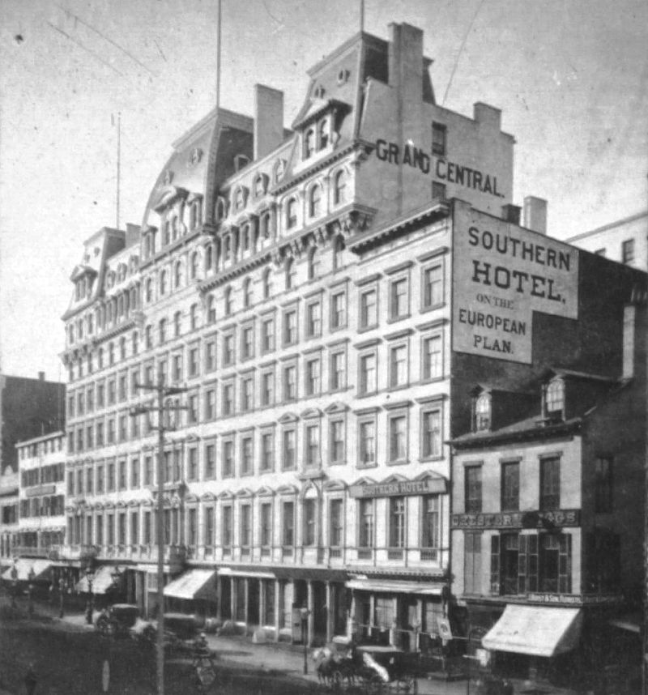

Concourse Plaza Hotel, 900 Grand Concourse, at 161st Street, The Bronx. Nearest subway station: 161st Street-River Avenue, 4, B, D trains. The hotel was opened in 1923 by Governor Alfred E. Smith himself, who said, “After seeing this new structure, I am convinced that anything can go in The Bronx.” The hotel was the borough’s leading location for business, social, and fraternal events. Democratic presidential candidates, including John F. Kennedy, made regular stops there for rallies, usually at the behest of Bronx Democratic Party boss Ed Flynn. The hotel had two kitchens, one kosher, a grand ballroom, and four smaller ballrooms. Tito Puente played the grand ballroom every New Year’s Eve.
The hotel’s baseball connections were firmed up very quickly, as Yankee ballplayers from Babe Ruth to Mickey Mantle and Roger Maris – and their families – would live there for the entire season, in a group of apartments the Yankees rented for the duration of the season. Visiting teams often stayed there as well, for convenience.
In the 1960s, The Bronx’s economic difficulties also caused a downward spiral for the hotel, and it became accommodation for welfare recipients. However, Yankee second baseman Horace Clarke, who would unintentionally stamp his name on an era of team incompetence, also lived there through the hotel’s decline, citing its inexpensiveness and proximity to Yankee Stadium.
In the early 1970s, an irate resident shot and killed a hotel manager, and in 1974, the city turned the hotel in to a senior citizens’ residence. There is probably no link between the shooting and the fact that the hotel contained a private basement rifle range.
Doral Inn, 541 Lexington Avenue, Manhattan. Nearest subway station: 51st Street, 6 train. This hotel was the scene of negotiations for the 1981 baseball strike. Talks were held on the 17th floor, and the Crystal Room on the Second Floor was the press room, used by the media to await announcements at the close of each day’s negotiations. Both the beginning and end of the strike were announced there.
Ansonia Hotel, 2109 Broadway, Manhattan. Nearest subway station: 72nd Street, 1, 2, 3 trains. Erected between 1899 and 1904, this legendary hotel was the home to many equally legendary people, including Florenz Ziegfeld, Angelina Jolie, Natalie Portman, Jack Dempsey, and, of course, Babe Ruth.
In addition, it was the site where Chicago White Sox first baseman Chick Gandil, who had an apartment in the hotel, met with his teammates – Happy Felsch, Lefty Williams, Ed Cicotte, Shoeless Joe Jackson, Fred McMullin, and Buck Weaver – to discuss the plot to “throw” the 1919 World Series, at the behest of fellow Ansonia tenant, “the Big Bankroll,” Arnold Rothstein.
Today the hotel, lavishly restored, is an apartment building. It was one of the first hotels in New York to have air conditioning.
Additional sites
Ruppert Brewery, 90th to 94th Streets, between 2nd and 3rd Avenues, Manhattan. Nearest subway station: 86th Street, Q train (Second Avenue) or 86th Street, 4, 5, 6 train (Lexington Avenue. Once the nation’s largest and most successful brewery, the 35 fortress-like building complex was the basis of Col. Jacob Ruppert’s ability to purchase the Yankees with Col. Tillinghast L’hommedieu Huston and then buy out Huston. With a Prohibition pause to produce bubble gum and near-beer that was sold at Yankee games, the brewery churned out beer until 1965, when it was torn down and replaced by the present-day housing towers. The Colonel’s Knickerbocker label was sold to Rheingold that year.
Col. Ruppert also ran his Yankee dynasty from his offices in the brewery, and it was here that a chastised Babe Ruth promised to obey his manager, Miller Huggins.
A park and playground in the area honors Col. Ruppert.
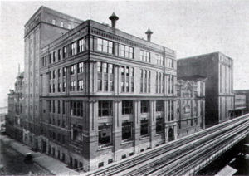
Lou Gehrig birthplaces, 309 East 94th Street, or 1994 Second Avenue (at 102nd Street). The former site can be reached by subway at 96th Street, 6 train. The latter site is accessed by subway at 103rd Street, 6 train, both on Lexington Avenue.
Biographies of Lou Gehrig say he was born in a house at 1994 Second Avenue, which ultimately became Dmitri’s Garden Center, and was marked by a plaque, until the garden store vacated the premises. No plaque remains.
However, in 1990, the Yankees placed a plaque at 309 East 94th Street, which is now part of the Mt. Sinai Medical Center complex, declaring that the Iron Horse’s birthplace. Sometime after that, his family moved to Washington Heights, and there is no question that he graduated from Commerce High School and attended Columbia before making his Yankee debut.
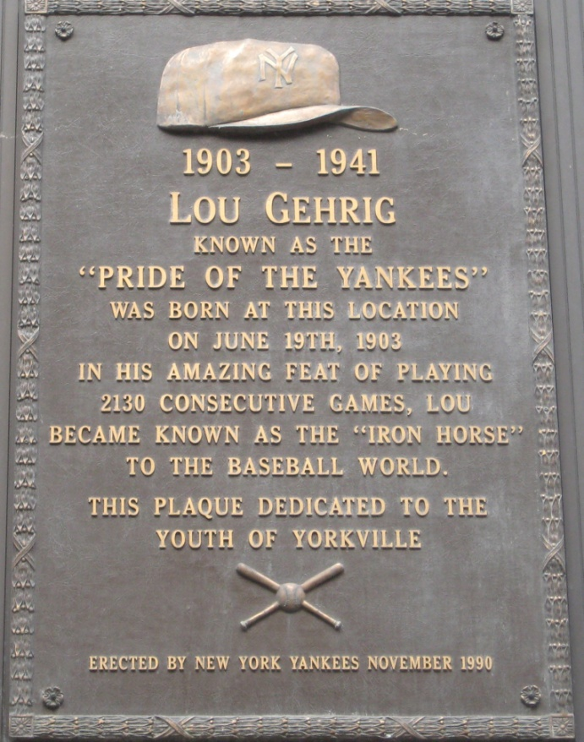

Elysian Fields, 11th Street and Washington Street, Hoboken, New Jersey. Reached by PATH train to Hoboken and No. 163 NJ Transit Bus or No. 163 NJ Transit bus from Port Authority of New York and New Jersey.
The highly organized New York Knickerbockers played their first official match under the new rules for baseball devised by their manager, Alexander Joy Cartwright, on this spot, and endured baseball’s first upset, falling 23-1 to the New York Base Ball Club. For years, New York and New Jersey teams used the sitefor baseball games. A marker placed here in 1986 by the city and unveiled by Yankee Hall of Famer Phil Rizzuto honors this landmark event in baseball history.
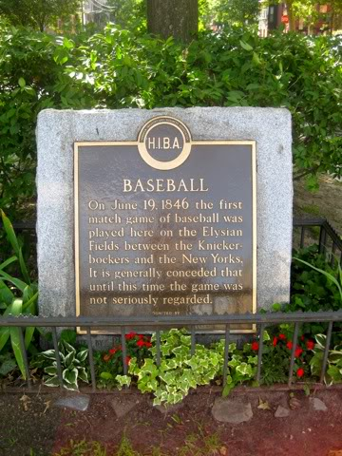

Yogi Berra Museum and Learning Center, 8 Yogi Berra Drive, Little Falls, New Jersey, 07424 P: 973.655.2378.
Located on the campus of Montclair State University, this unique museum and educational center honors the life and legacy of one of America’s most beloved athletes and wits and his four values: excellence, perseverance, respect, and sportsmanship. Permanent exhibits display artifacts from his Hall of Fame baseball career, World War II US Navy combat service, and his role as a cultural icon. The museum is open Noon to 5 p.m., Wednesdays through Sundays. Admission: $6 for adults, $4 for youth under 18, and $5 for seniors.

Bookstores
Austin Book Shop, 104-29 Jamaica Avenue, Queens. Nearest subway station, 104th Street, J, Z trains. Open Saturdays only, 10 a.m. to 4 p.m. Opened in 1954, this store developed a specialty on books on baseball, and has the largest collection of out-of-print baseball books in the nation.
Bergino Baseball Clubhouse, 67 East 11th Street, Manhattan. Nearest subway station, 14th Street-Union Square, 4, 5, 6, N, R, Q, V, L trains. One of the vendors at SABR 47, their main store is located in the historic “Cast Iron Building” and offers an amazing array of vintage baseball items ranging from historic artwork to t-shirts, baseballs, and yarmulkes.
The Strand Bookstore, 828 Broadway (northeast corner of East 12th Street. Nearest subway station, 14th Street-Union Square, 4, 5, 6, N, R, Q, V, L trains. Hours: 9:30 a.m. to 10:30 p.m. Monday through Saturday, 11 a.m. to 10:30 p.m., Sundays. This legendary bookstore offers 18 miles of books on nearly every conceivable subject, with outdoor shelves of $1 and $2 books. Baseball books are downstairs. The store also offers unique buttons and t-shirts.

There are a great many more historic baseball sites in the New York area: Babe Ruth, Lou Gehrig, Billy Martin, and Jacob Ruppert are all buried in cemeteries just north of the city. Alex Rodriguez, Richie Scheinblum, Manny Ramirez, Ed Kranepool, Joe Torre, and Joe Pepitone are just some of the major league stars who were born in the city. SABR members who have studied these subjects will have an opportunity before, during, and after the Convention to explore these sites for themselves. Enjoy!
